**Report on Implementation of Te Tiriti o Waitangi at Berkley Normal Middle School (2023)**

Te Tiriti o Waitangi, signed in 1840, is a foundational document in Aotearoa New Zealand, guiding principles of partnership, participation, and protection. Berkley Normal Middle School acknowledges its commitment to honouring the principles of Te Tiriti o Waitangi and endeavours to embed these principles into the fabric of its educational practices.

Berkley Normal Middle School continues to foster partnerships with local iwi (tribes) and Māori community leaders. Throughout 2023, the school maintained regular communication and collaboration with iwi representatives to ensure their perspectives are integrated into decision-making processes. This partnership has been instrumental in developing policies and practices that respect and incorporate Māori cultural values within the school environment. Our kapa haka groups have been showcasing cultural performances in local schools and community venues e.g. hospice. These activities have strengthened community ties and provided opportunities for students to connect with their cultural heritage in meaningful ways.

In 2023, Berkley Normal Middle School enhanced opportunities for meaningful participation of Māori students, whānau (families), and community members. The school actively sought feedback from Māori stakeholders through hui (meetings) and schoolwide community surveys, ensuring their voices were heard in discussions about curriculum, policies, and cultural initiatives. This inclusive approach has strengthened relationships and increased engagement among Māori students and their families.

Protecting Māori language, culture, and identity remains a priority at Berkley Normal Middle School. The school continued to offer te reo Māori (Māori language) classes at various levels, encouraging students and staff to learn and embrace the language. Cultural protocols were respected and observed during school events and ceremonies, demonstrating a commitment to preserving and celebrating Māori heritage.

| **4.1 LOCAL IWI** | | | |
| --- | --- | --- | --- |
| **strengths** | **opportunities** | **aspirations** | **results** |
| We have strong iwi partnerships that are culturally responsive | Opportunities exist to:  1 Strengthen our existing partnerships;  2 Build teacher knowledge of our local iwi partners;  3 Connect to expertise in our community;  4 Grow CRP in our team;  5 Implement the new NZ Histories Curriculum;  6 Ensure our environment expresses that all people have a place and belong.  7. Leverage connections through the Kahui Ako. | Berkley is a place where all learners feel that they have a place and belong  A stronger presence of local iwi is established in the school.  Teachers can articulate and plan for culturally responsive practice. | We continue to strive to better meet the needs of Te tiriti o Waitangi.  Maori students and whanau identify Berkley as ... |

2023 Strategic Plan Goals:

| **3.1 TE AO MÁORI** | | | |
| --- | --- | --- | --- |
| **strengths** | **opportunities** | **aspirations** | **results** |
| The school is committed to an ongoing integration of Te Reo and Tikanga Maori | We have an opportunity to evaluate the engagement with, and response to our partnership to Te Tiriti o Waitangi,  Te Reo, Tikanga Maori, Bi-lingual, Full immersion | A statement of intent and action plan has been co-constructed with stakeholders during 2022 | Statement of Intent completed. 'Next steps' for 2023 being actioned. |
| Application for PLD pending for 2023 to continue work with facilitators. Poutama reo used as evaluation tool at end of 2022. Survey results show positivity towards potential bilingual class however we still need community consultation and input for hapu/iwi in decision making moving forward. Mark will be released for a fixed term trial as a Te reo tutor in order to build capacity across all staff and students in Te Reo and to continue the strong work undertaken in teaming this year., Consultation with whanau hui is an ongoing focus | | | |

Throughout 2023, Berkley Normal Middle School continued to integrate Māori perspectives across the curriculum. This included incorporating significant events, histories, and cultural practices into subject areas such as social studies, the arts, and physical education. Teachers received professional development opportunities to enhance their cultural competence, ensuring they could effectively incorporate Māori content into their teaching practices. Regular teaching of the New Zealand histories curriculum and linking units of inquiry to local stories have been prioritised at Berkley Normal Middle School. This approach ensures that students gain a comprehensive understanding of both national and local histories, incorporating diverse perspectives and narratives. Below are the four units covered with links to NZ Histories Curriculum

1: **Culture and Identity**

People's culture and identity has an impact on their actions.

NZ Histories link - Maori history is the foundational and continuous history of Aotearoa New Zealand

2. **Place and Environment**

Communities change through crisis and human displacement.

NZ Histories link - Relationships and connections between people and across boundaries have shaped the course of Aotearoa New Zealand Histories

3. **Organisation**

The movement of people and ideas has an impact in the past, present and future.

NZ Histories link - Colonisation and settlement have been central to Aotearoa New Zealand histories for the past 200 years

Big Ideas

NZ has its own Migration stories

Key learning: That Te Tiriti o Waitangi was conceived as a response to the changing movement of people into and around NZ and that it was and is seen differently by different people - Migration vs colonisation.

4. **Scarcity/Sustainability**

Earth's resources are limited and essential to life.

NZ Histories link - The course of Aotearoa New Zealand histories have been shaped by the use of power

Matariki Week - we also dedicate a week of learning and celebration including school wide Hangi on the last day of the week.

During the 2023 academic year, Berkley Normal Middle School Board of Trustees prioritised and funded a full-time Te Reo Māori teacher dedicated to providing professional Te Reo development to all staff members, and providing equal opportunities to all students to engage and upskill with Te Reo. This teacher worked collaboratively with educators across all classes, upskilling them and students in Te Reo and Tikanga Māori for 1 hour and 20 minutes every two weeks. This initiative has significantly enhanced the school's capacity to integrate Te Reo and tikanga into everyday teaching and learning. Below are some changes we have made since implementing this role

* Whole school Powhiri - all students able to run a successful powhiri whenever there is an opportunity in our school
* With a community response to our school wide survey, Berkley is no longer an IB school. This allowed us to deepen our commitment to TOW with an opportunity to incorporate WERO values. We consulted staff, community including Maori leaders and students in regards to this change and produced the following:

W - Whanau

E - Ekea

R - Raakau

O - Ora

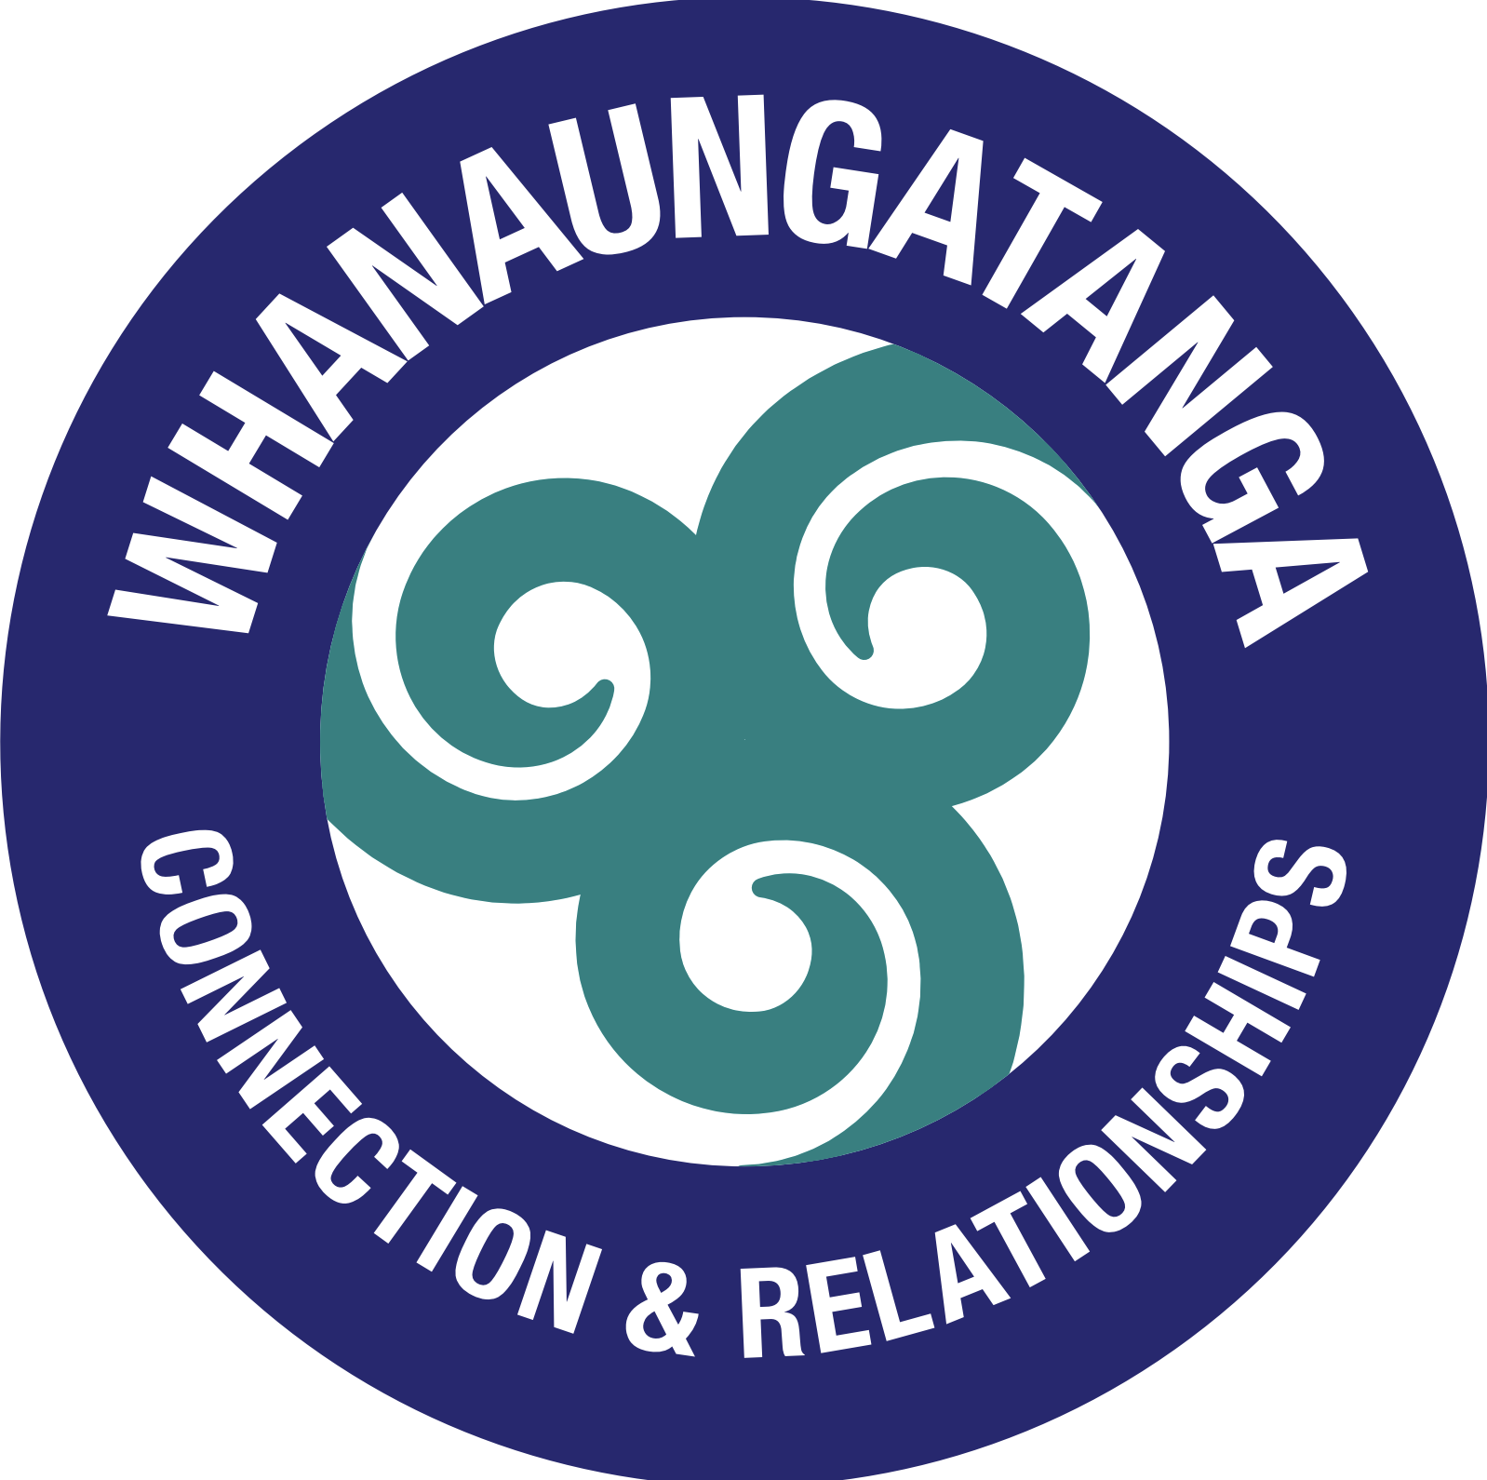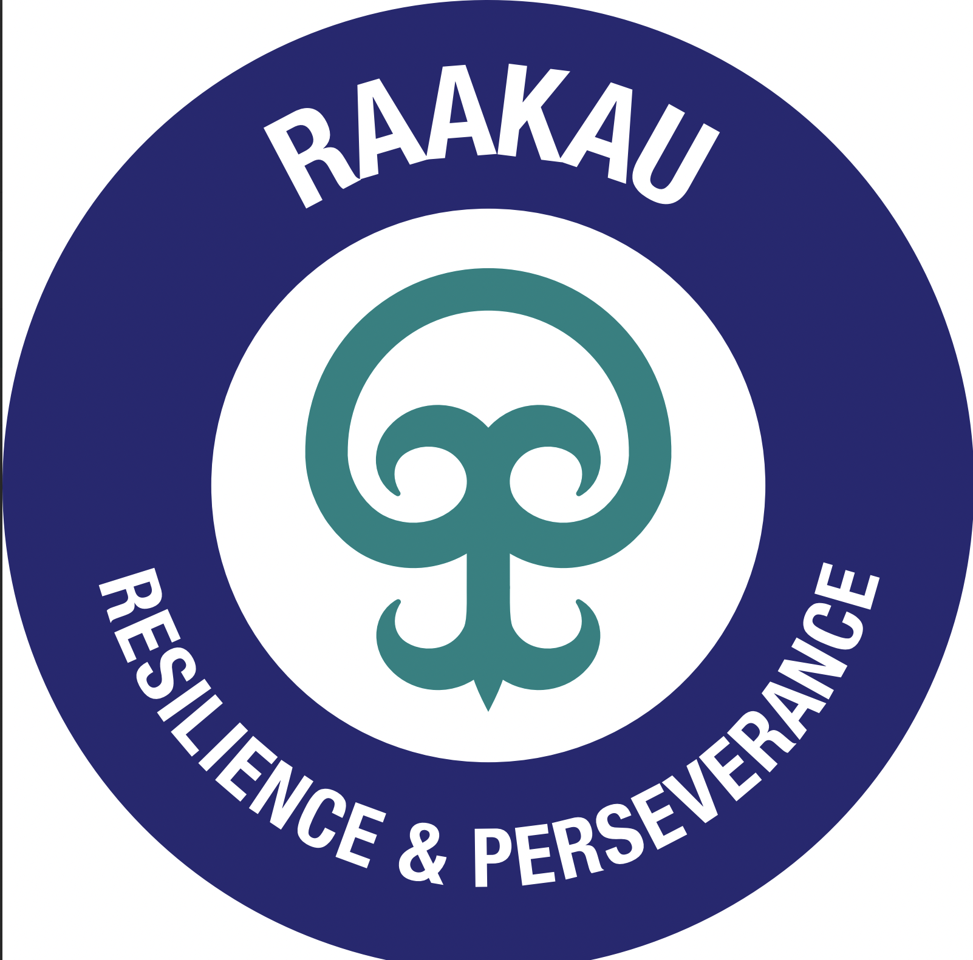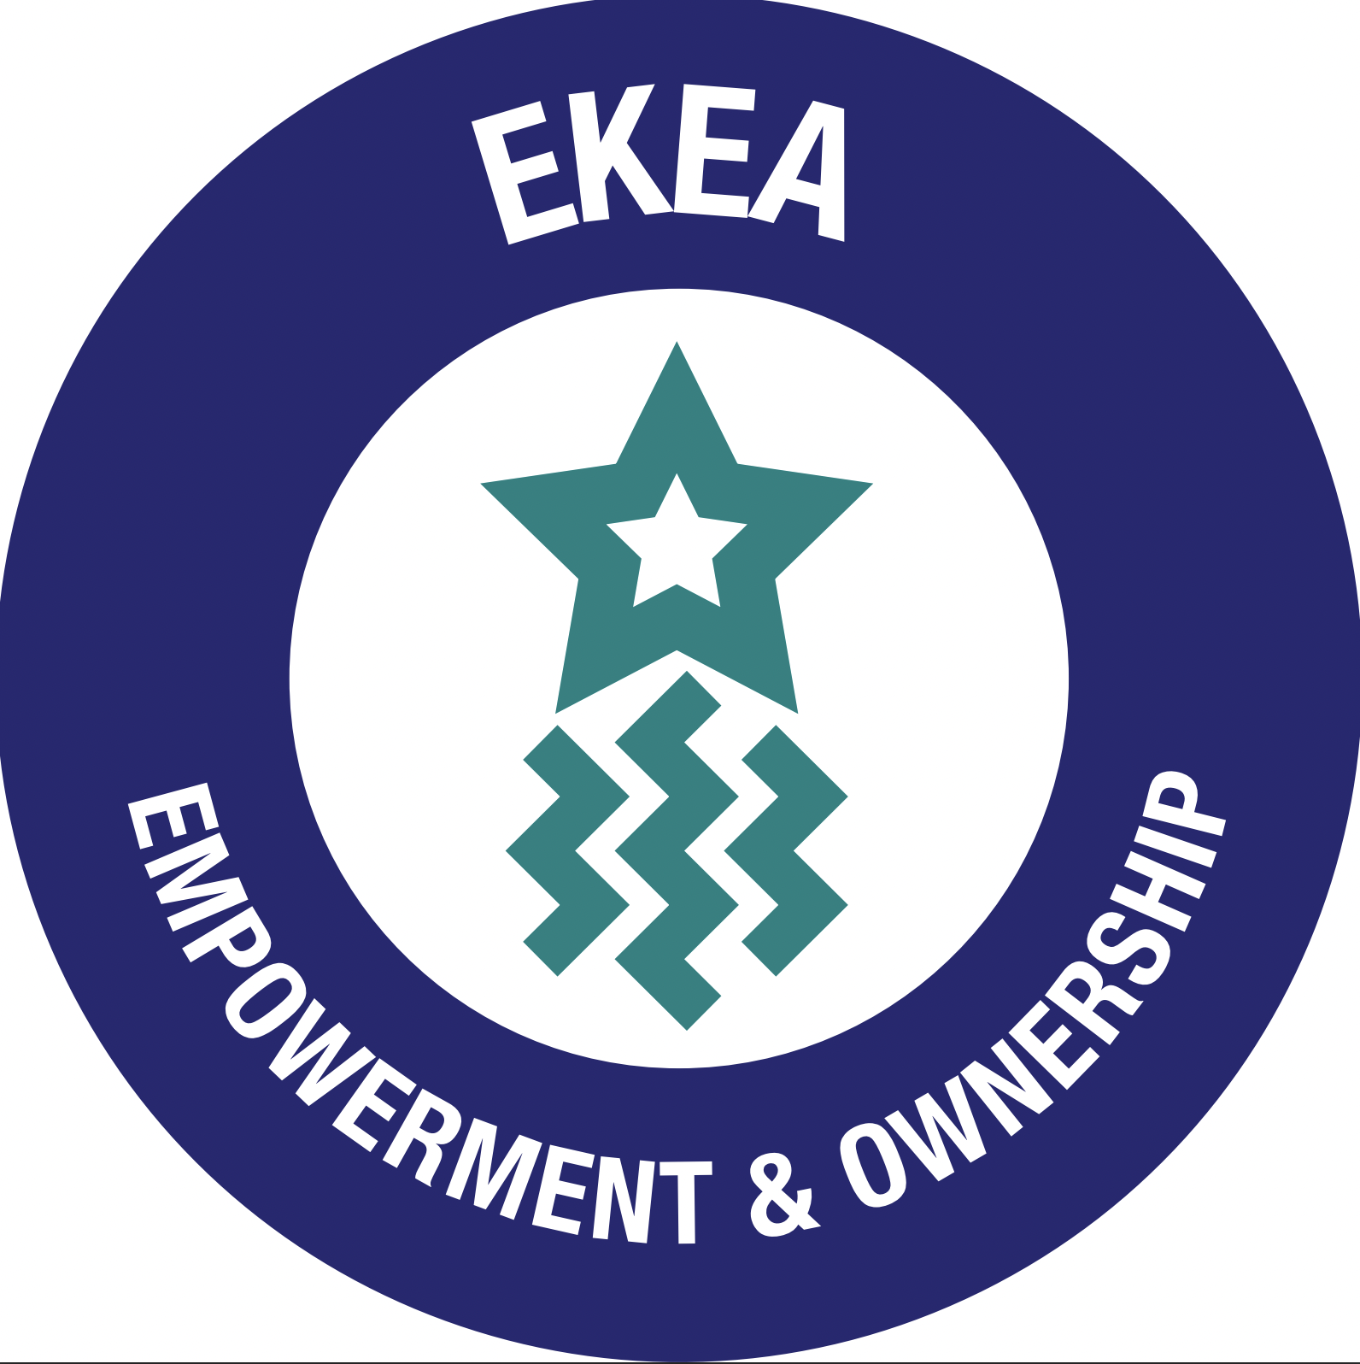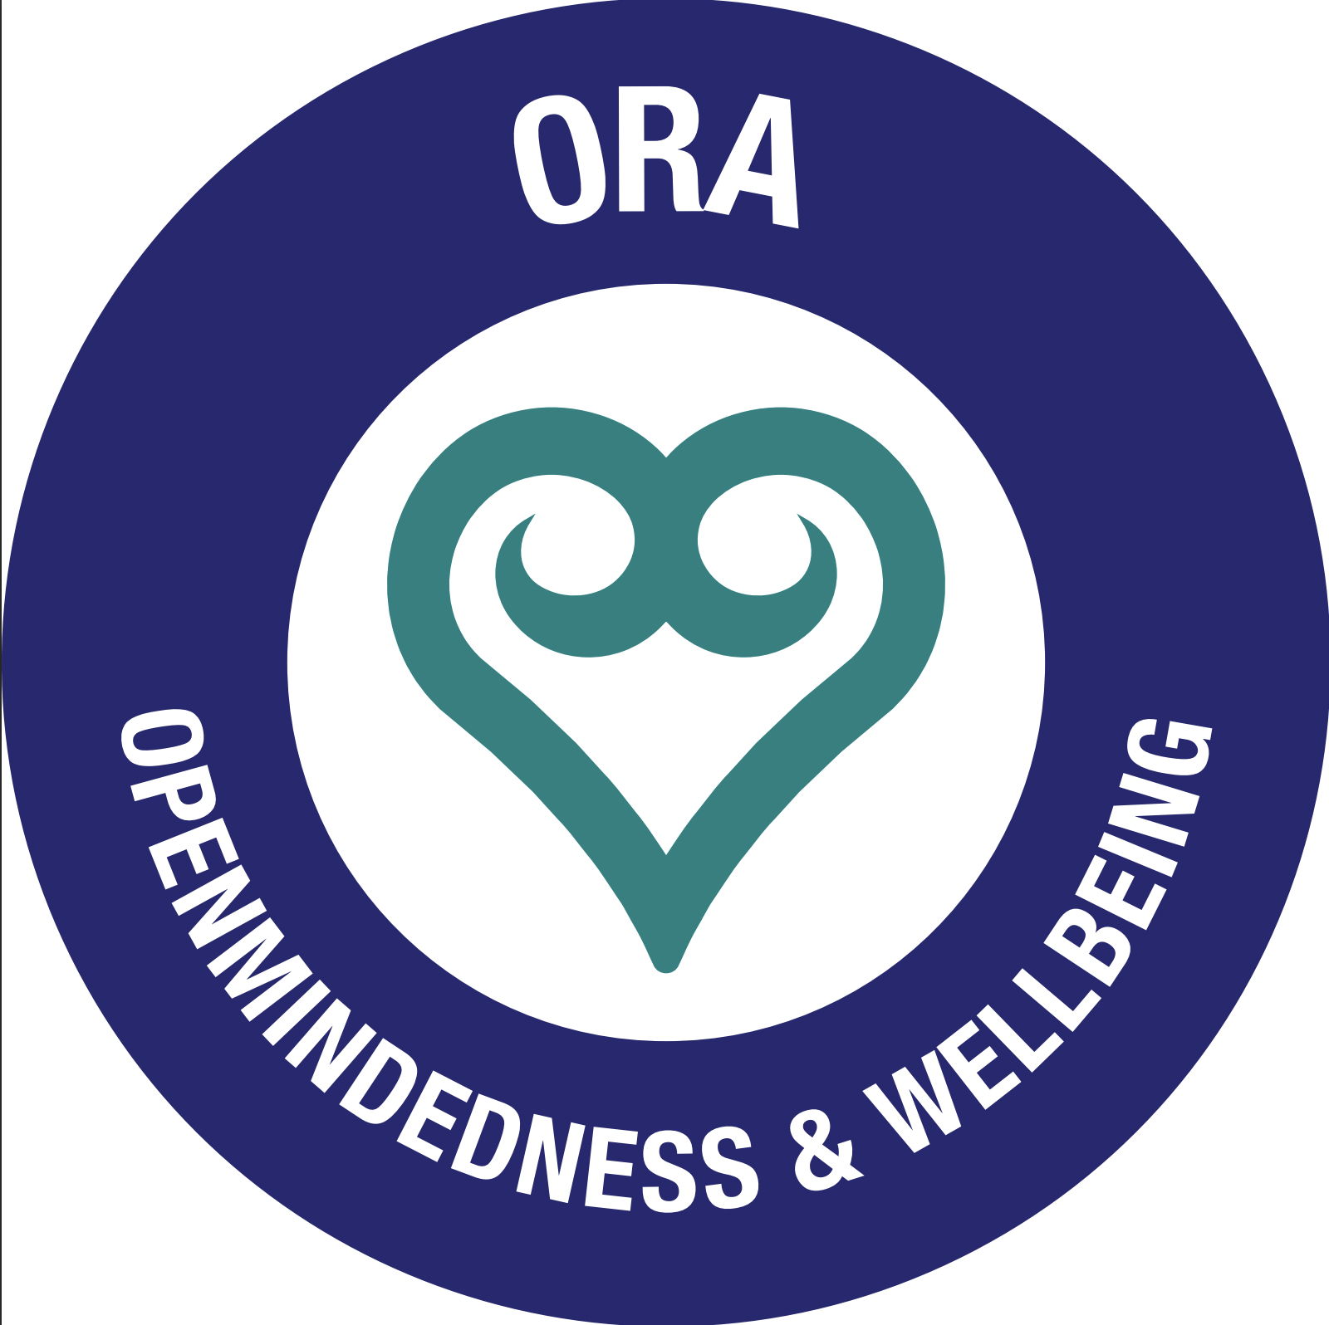

In conclusion, Berkley Normal Middle School has demonstrated a steadfast commitment to honouring Te Tiriti o Waitangi throughout the 2023 school year. Through robust partnerships, increased participation of Māori stakeholders, protection of Māori language and culture, extensive curriculum integration, professional development in Te Reo Māori, and active engagement in cultural activities, the school continues to uphold the principles of Te Tiriti o Waitangi. Moving forward, Berkley Normal Middle School remains dedicated to further advancing these efforts, fostering an inclusive and culturally responsive learning environment for all students.